Alpha - Version
USER INTERFACE
(User Interface Documentation)
Project: HCBP Sand Mixer Report System
Plant: High Chrome Ball Plant
Version: 1.0.0.0
Prepared by: Tsundzukani Nkuna
From Date: 2025/ 06/ 23 To Date: 2025/ 06/ 24

Contents
Introduction 1
2. Navigation Links That help User Navigate with HCBP Sand Mixer Report System. 1
3. User Filters and Buttons 2
4. Sand Batches Minimum and Maximum 2
5. Sand Mixer Summary 2
6. Line 1 Sand Batches 3
7. Line 2 Sand Batches 4
8. Line 3 Sand Batches 5
9. Process Flow Diagram 6

Introduction
This Document is a review of User interface final Produced Product for an HCBP Sand Mixer Report System.

2. Navigation Links That help User Navigate with HCBP Sand Mixer Report System.
  - Sand Mixer Summary
  - Sand Mixer Line 1
  - Sand Mixer Line 2
  - Sand Mixer Line 3
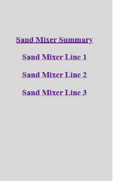

User Filters and Buttons
  - Filter By Start Date and End Date Time
  - Search by Date Time (Button)
  - Generate Report (Button)
  - Download .PDF (Button)
  - Export to Excel (Button)
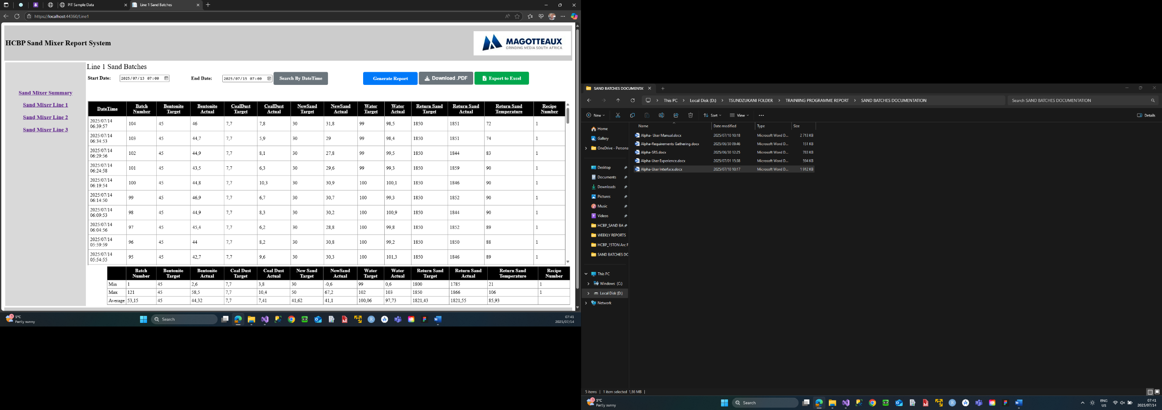

Sand Batches Minimum and Maximum
  - Display Sand batch Target and Actual Minimum Value
  - Display Sand Batch Target and Actual Maximum Value
  - Display Sand Batch Target and Actual Average Value

Sand Mixer Summary
    - When you run the HCBP Sand Mixer Report System the Sand Mixer Summary is a start-up page.
            - Activities you can do on HCBP Sand Mixer Report Summary
                - Search Line 1, Line 2 and Line 3 by Date Value.
                - Generate Report Button (Blue in Colour) takes you to sand mixer summation page with Current Date Reports.
                - Download .PDF (Grey in colour) download the current page content.
                - Export to Excell (Green in colour) Export Displayed Data to excel despite the date search.
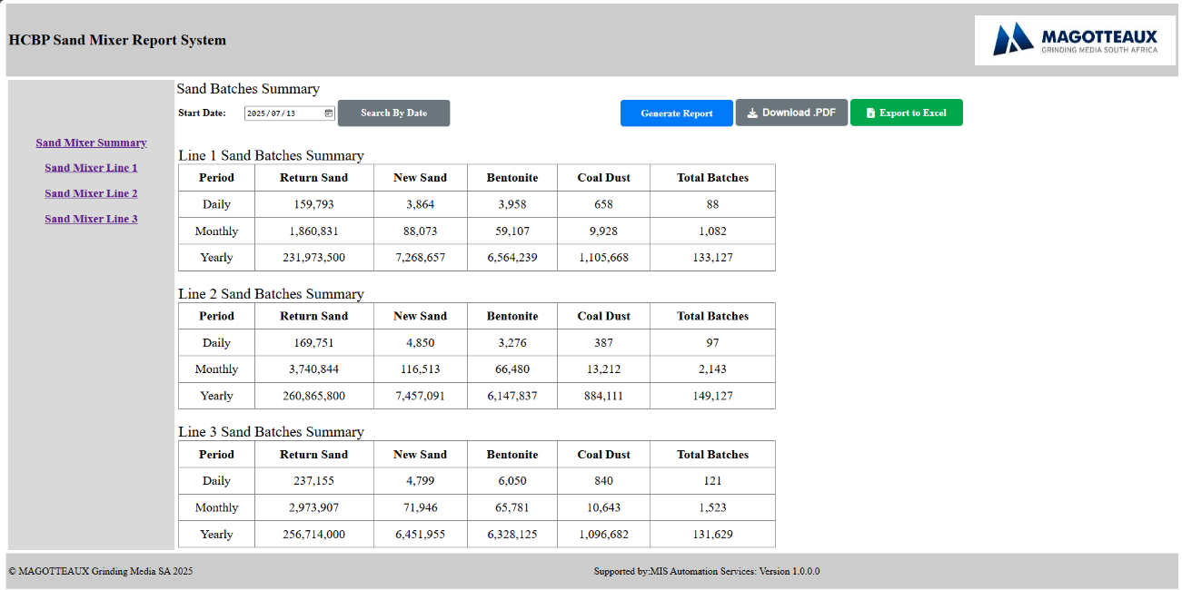

Line 1 Sand Batches
    - On Navigation Links when a user takes a decision to view Sand Mixer Line 1.
            - Activities you can do on HCBP Sand Mixer Line 1
                - Search Line 1 Sand Batches by Date and Time Value.
                - Generate Report Button (Blue in Colour) takes you to sand mixer summary page with Current Date Reports.
                - Download .PDF (Grey in colour) download the current page content.
                - Export to Excell (Green in colour) Export Displayed Data to excel despite the date and Time search.
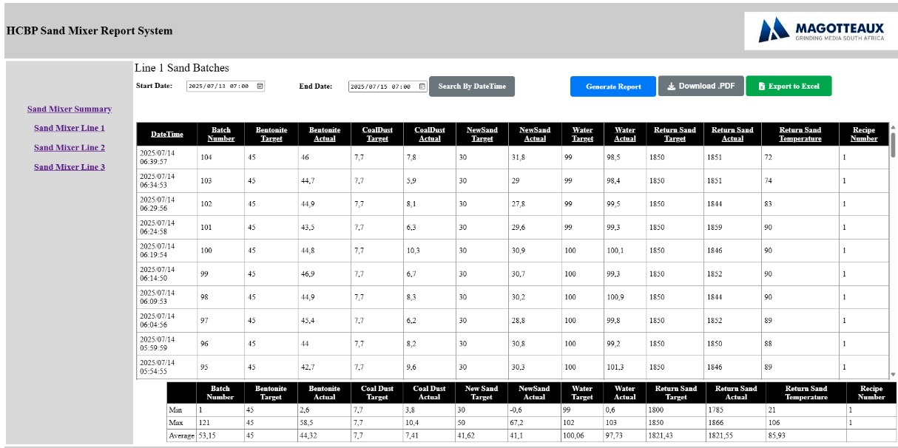

Line 2 Sand Batches
    - On Navigation Links when a user takes a decision to view Sand Mixer Line 2.
            - Activities you can do on HCBP Sand Mixer Line 2
                - Search Line 2 Sand Batches by Date and Time Value.
                - Generate Report Button (Blue in Colour) takes you to sand mixer summary page with Current Date Reports.
                - Download .PDF (Grey in colour) download the current page content.
                - Export to Excell (Green in colour) Export Displayed Data to excel despite the date and Time search.
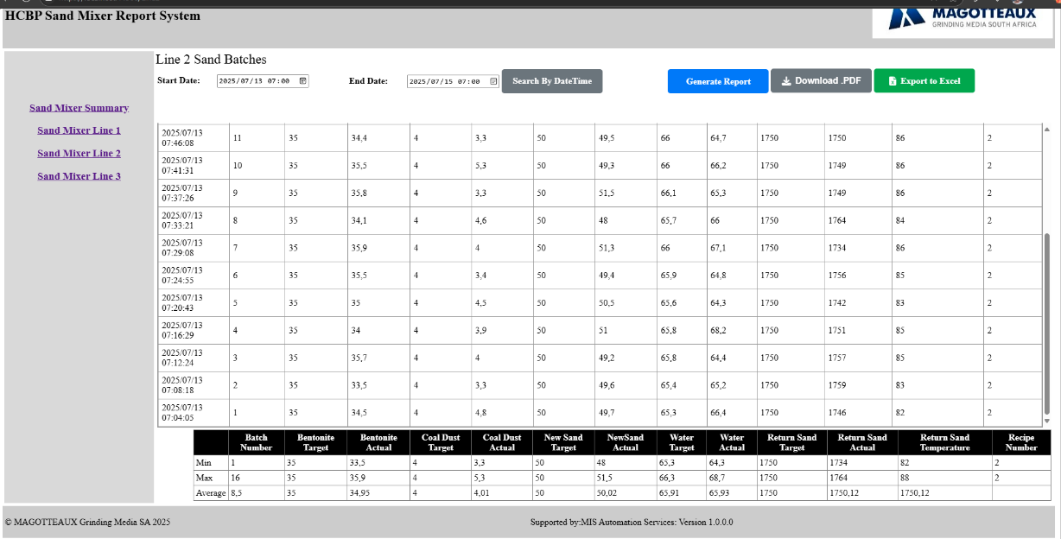

Line 3 Sand Batches
    - On Navigation Links when a user takes a decision to view Sand Mixer Line 3.
            - Activities you can do on HCBP Sand Mixer Line 3
                - Search Line 3 Sand Batches by Date and Time Value.
                - Generate Report Button (Blue in Colour) takes you to sand mixer summary page with Current Date Reports.
                - Download .PDF (Grey in colour) download the current page content.
                - Export to Excell (Green in colour) Export Displayed Data to excel despite the date and Time search.

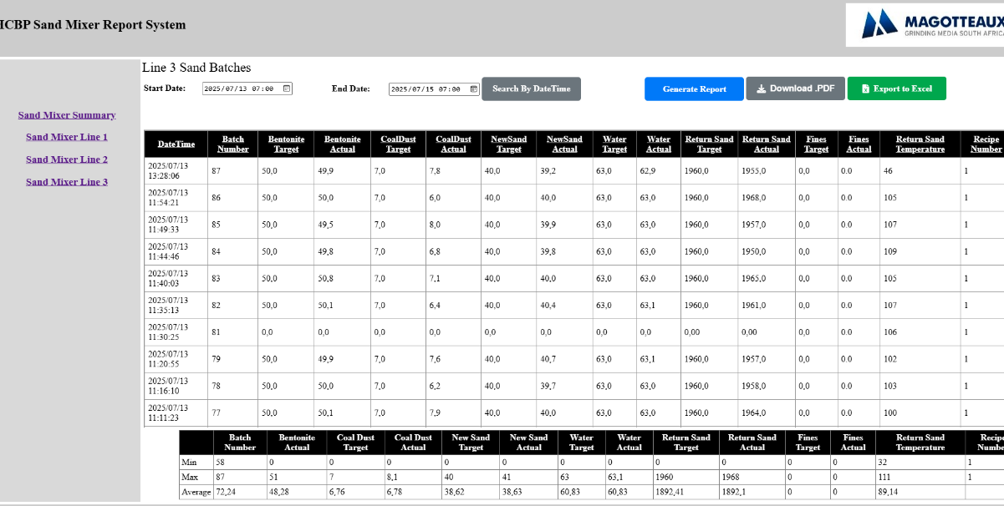

Process Flow Diagram
